Open Source Sex Machine

Assembly Guide

Table of Contents

Parts Checklist 3

Purchased Parts 4

Printed Parts 5

Assembly Instructions 6

Mate the Base Plate with the Motor 6

Build up the belt guides 7

Install and Align the Pulley 8

Linear Rail Installation 9

Belt Placement 11

Belt Tensioner 11

Wrap Belt Around Pulley 12

End Effector Belt Clamp 13

# Parts Checklist

The Github list is always to be considered to be more up-to-date than this document, if there are discrepancies please visit the Discord and ask for clarification in #OSSM

This guide is for the complete OFFICAL OSSM, however there are many modifications that you may choose to make for your specific build.

## Purchased Parts

|  |  |  |  |
| --- | --- | --- | --- |
|  | |  | |
| Nema 23 Servo Motor – IHSV57-30-10  100W is Standard, optional to use 140W or 180W models.  Avoid the *StepperOnline* version because of compatibility issues | |  | |
| OSSM PCB & Remote | |  | |
| GT2 Pulley – 20 Tooth, 8mm Bore | | Thumbnail image of a Lens result | |
| GT2 Timing Belt – 6mm Width x 600mm  Get a bulk amount of belt  600mm is a minimum for a standard build | | GT2-2M Timing Belt - By the Foot - OpenBuilds Part Store | |
| Roller Bearings – 5x11x4mm (Qty:6) | | MR115-2RS Ball Bearing 5x11x4mm Compatible with Traxxas 5116,5x11mm ABEC-3  Blue Rubber Sealed Ball Bearings (Pick of 10pcs) : Amazon.ca: Industrial &amp;  Scientific | |
| 24v 6A fully enclosed power supply  Look for one that is certified for use in your country | | Auplf 24 Volt 6 Amp Power Supply Adapter Converter Regulator, 5.5mm x 2.1mm DC Plug, Output 12V 6A 72W Wall Plug Switch for DC12V 5050 LED Strip Light (24V-6A) | |
| Metric Cap Screw Kit  Should be about $20 USD, M5, M4, and M3 are used in the build in various lengths  Most M5 cap head screws are 20mm long | |  | |

## Printed Parts

|  |  |
| --- | --- |
| Base |  |
| Middle |  |
| Standard Cover |  |
| Belt Tensioner (Elims’ Design) |  |
| Threaded End Effector Adapter – 24MM |  |
| 24MM Jam Nut |  |

# Assembly Instructions

## Mate the Base Plate with the Motor

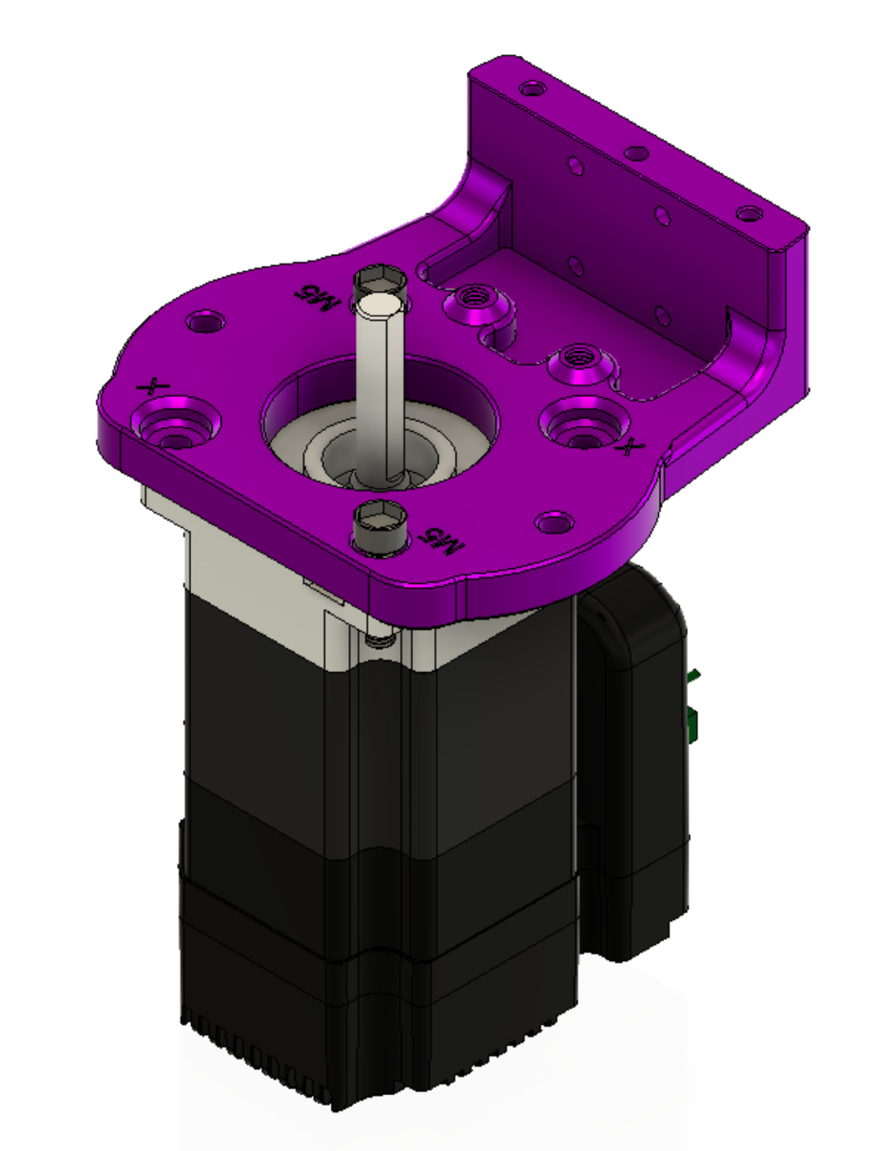Attach the OSSM base plate to the motor with (2) 5x20mm cap head screws in the locations marked *M5* and tighten with a M5 nut below the motor mounting flange.

## Build up the belt guides

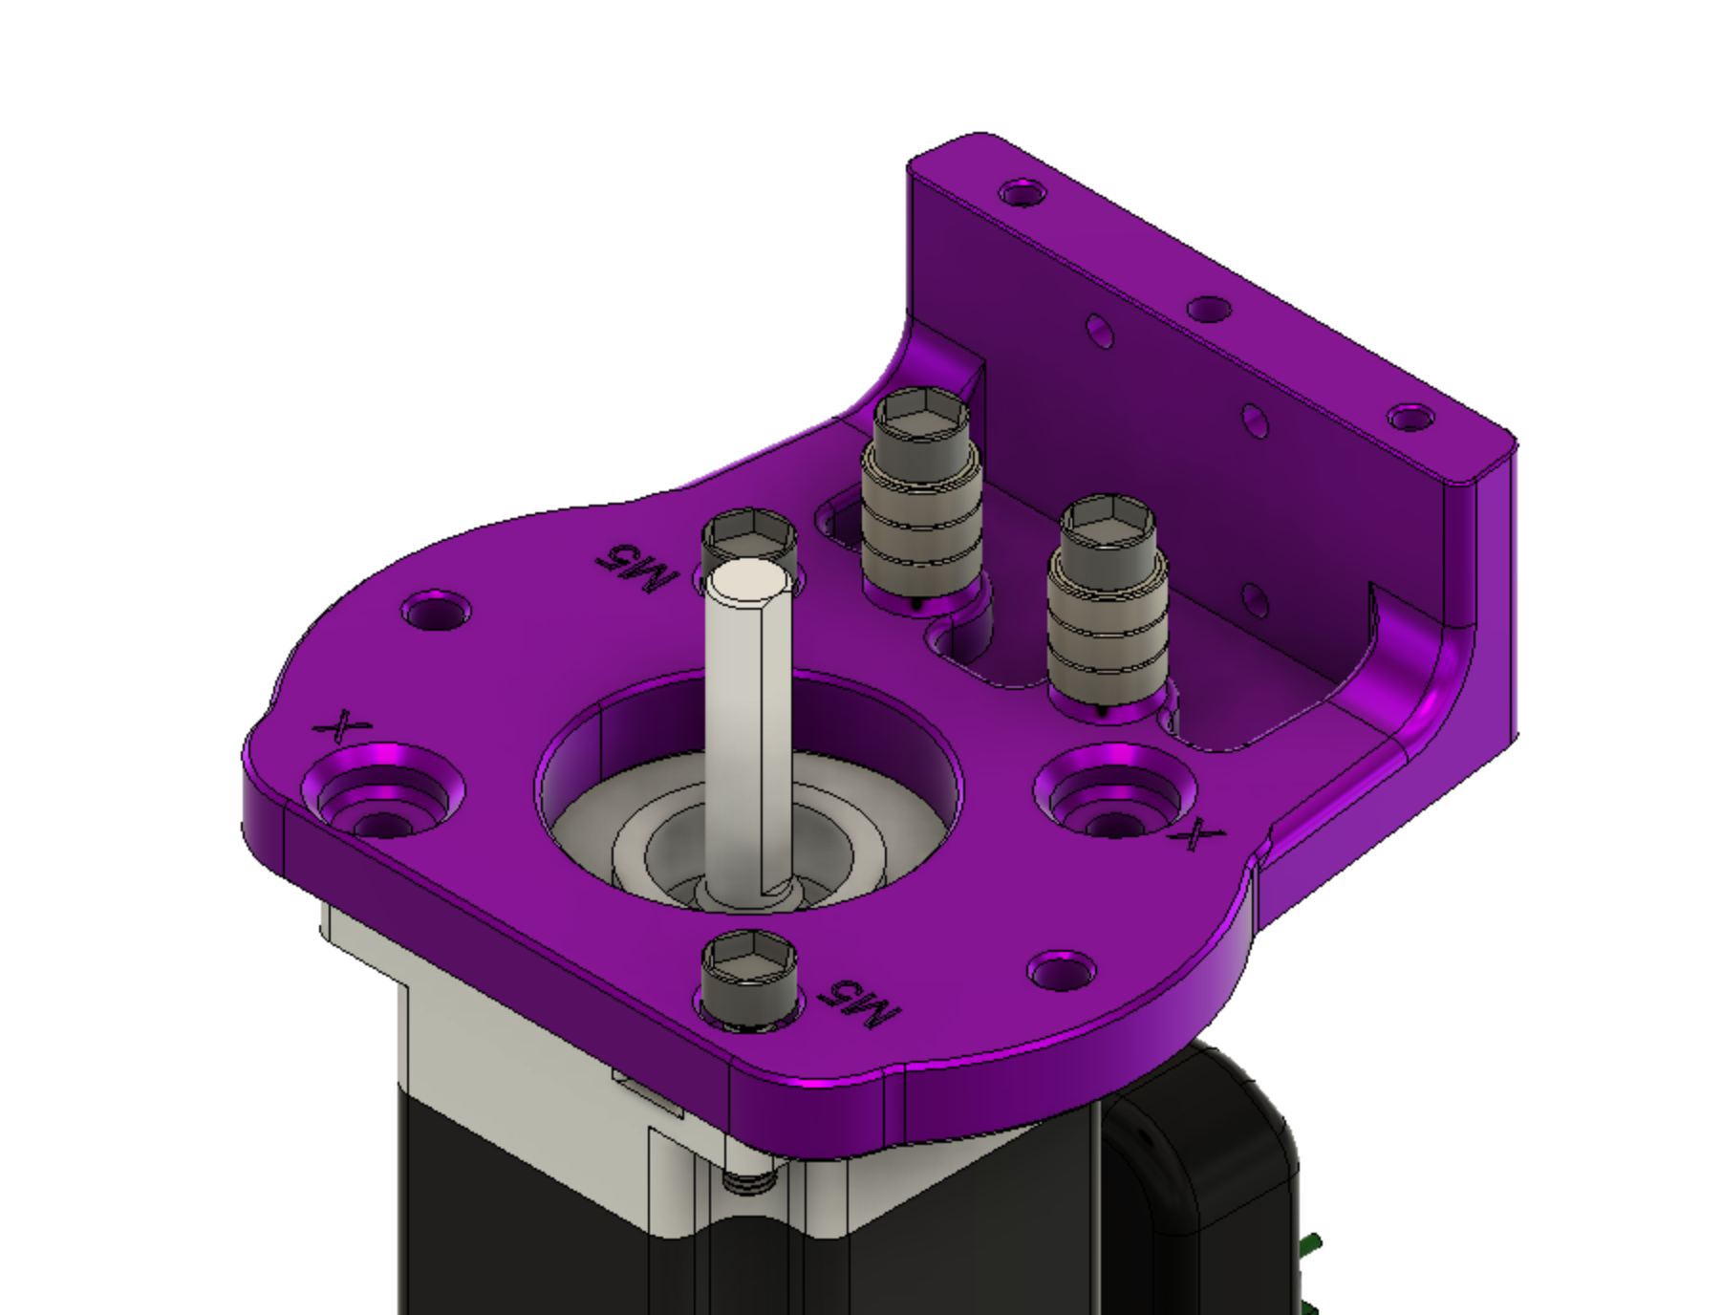

The bearing stacks are built up around 5x20mm cap head screw

Stack three 5x11x4mm bearings on a 5x20mm cap head screw and attach to the threaded positions in the baseplate as shown above.

## Install and Align the Pulley

Mount the 20 tooth GT2 Pulley on the shaft of the motor

## Linear Rail Installation

Align the pulley so that it is within the range of the bearings and the set screws that clamp it to the motor shaft are available from above the base plate

MGNRH Rail and Bearing are next*. linear rail is omitted from this view.*

**Try not to separate bearing from linear rail, there is a chance of losing ball bearings when the rail and bearing are separated**

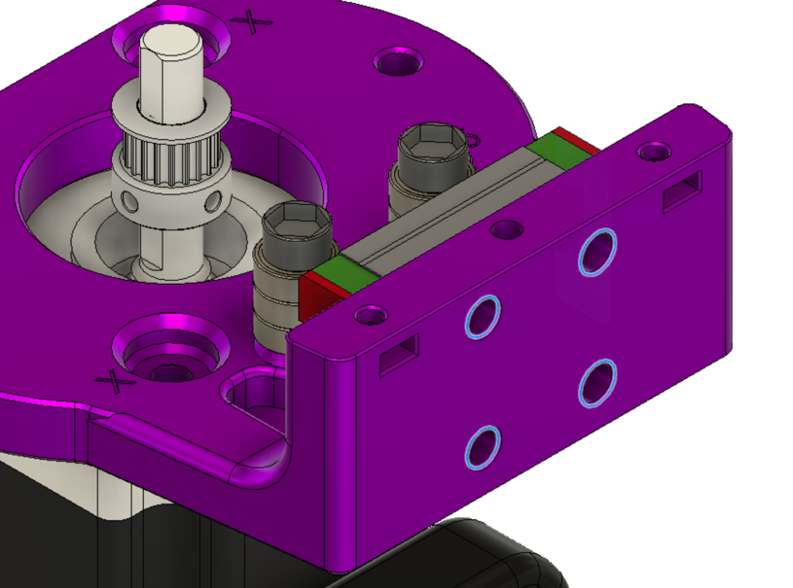

Highlighted holes for M3 cap screws. The cap screws should finish flush with surface when fully tightened.

Attach the middle part of the OSSM body utilizing the remaining diagonal holes. The M5x20mm shown above being inserted into the correct positions.

## Belt Placement

Now is time to place the belt in the iconic OSSM configuration. Using the clamp files provided to secure and tension the belt. The belt shown in orange is only approximate, the teeth on the belt are not show, but should face the pulley.

X-Ray View of entire belt path

### Belt Tensioner

Start with getting the belt placed into the tensioner, work the belt into the tensioner and use the M3 cross bolt to hold it in place. Then slip the assembly onto the end of the rail.

### Wrap Belt Around Pulley

Wrapping the belt around the main drive pully and past the stacks of idler pulleys will get the belt in the correct location.

### End Effector Belt Clamp

The belt routes through the end of the threaded adapter, this should be done off the rail and the slack in the belt should be taken up as the threaded adapter is slid on the rail.

Once the belt threaded adapter is in place and all of the extra belt has been pulled through the Jam Nut can be used to lock this end of the belt in place.

Congratulations!

(we hope) You should now have a mechanically assembled OSSM